eTracker request: - to add container weights information and container detail report.

1. Tracking list Header- add Tare Weight and Cargo Weight :

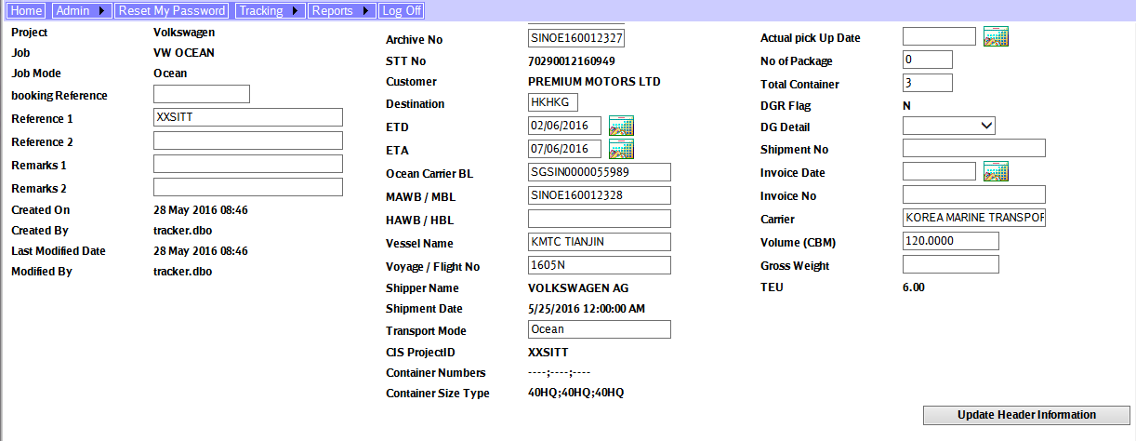

Gross Weight

Cargo Weight

Tare Weight

Add new fields – tare weight and cargo weight.

And re-align gross weight position.

1. Container Detail

* To add new fields: No of packages, Tare weight, cargo weight and gross weight at the end of the container detail information.

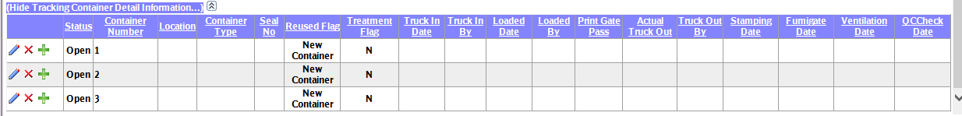

1. New Report – “Outbound Shipment - Container Detail”

Stored procedure: SCH_eTRACK_Report_Outbound_Shipment_by_ETD_ContainerDetail

Report criteria:

Project

ETD from and ETD to

Destination

Customer name

Status

Container#

